NATO SECRET approval for SINA
[Essen/Germany, 2 February 2015] NATO has approved the cryptography components SINA L3 Box H, SINA Workstation H and SINA Terminal H for its NATO SECRET security level. secunet is thus the only German manufacturer to meet NATO's requirements for IPsec solutions at this high degree of secrecy. With immediate effect, all NATO member states plus the entire NATO organisation and its units across the globe can use SINA for communications at security levels up to and including NATO SECRET.
“We are proud to have received this approval from NATO. It is a special form of recognition for us and what we have developed. The approval just goes to show that top-quality German cryptography products are also able to fulfil NATO's high demands," said Dr Rainer Baumgart, Chairman of the Management Board at secunet Security Networks AG. "This success, in addition to numerous national approvals and the EU approval granted only recently, paves secunet's way into new international markets."
Dr Gerhard Schabhüser, Head of the Cryptographic Technology department at the German Federal Office for Information Security (BSI), added: "The development of the SINA range of products, assigned by the BSI, was primarily intended for the use in the German government market and for the protection of the national IT-infrastructure. The NATO SECRET approval also confirms the security strategy of the BSI, including the high demands that it places on cryptography products."
About SINA
The SINA L3 Box, a virtual private network gateway, is a core component of the central IT infrastructure in high security networks. The data exchanged between the SINA L3 boxes are transmitted securely in encrypted VPN tunnels. SINA L3 boxes also serve as cryptographic network access points to server areas for SINA clients (e.g. the SINA Workstation).
The SINA Workstation H, now available to NATO, is a client with hard drive encryption, smart card authentication and IPsec-protected communication. The SINA Terminal H is a flexible VPN client without a hard drive that can be used in fixed or variable locations. It communicates with terminal servers via remote desktop protocols.
The SINA Workstation H and SINA Terminal H devices are multi-session-capable and can process both open data and/or data with varying levels of classification in parallel sessions, for example. This is an advantage particularly for NATO communications: the users often need to process information from a range of networks. They are now in a position to process the information on a single device instead of having to switch between various workstations (as has been the case to date). SINA thus offers not only security, but also considerable potential for savings.

Summary of current approvals:
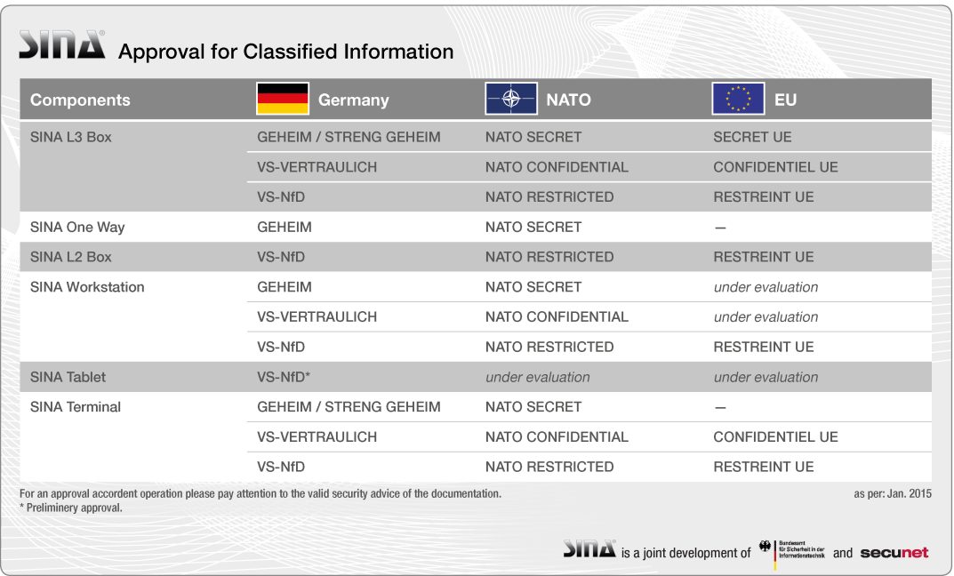

Number of characters: 2,774

Press contact

Christine Skropke
Spokesperson

Patrick Franitza
Dep. Spokesperson

secunet Security Networks AG
Kronprinzenstrasse 30
45128 Essen/Germany
Phone +49 201 54 54-1234
Fax +49 201 54 54-1235
E-mail: presse@secunet.com
http://www.secunet.com

About secunet

secunet is one of the leading German providers of high-quality IT security. Over 300 experts work in the areas of cryptography, e-government, business security and automotive security, and develop innovative products in these fields in addition to highly secure and reliable solutions. Many DAX companies as well as numerous authorities and organisations are among secunet's national and international customers, which total over 500. secunet is IT security partner of the Federal Republic of Germany and partner in the Alliance for Cyber Security.
secunet was founded in 1997 and achieved sales of EUR 82.2 million in 2014. secunet Security Networks AG is listed on the Prime Standard of the German Stock Exchange

Additional data is available from www.secunet.com

